**DAILY ONLINE ACTIVITIES SUMMARY**

|  |  |  |  |  |  |  |  |  |
| --- | --- | --- | --- | --- | --- | --- | --- | --- |
| **Date:** | **17/07/2020** | | | | | **Name:** | **SPOORTI DAROJI** | |
| **Sem & Sec** | **4th SEM. & ‘B’ SEC.** | | | | | **USN:** | **4AL18CS088** | |
| **Online Test Summary** | | | | | | | | |
| **Subject** | | **DATA COMMUNICATION** | | | | | | |
| **Max. Marks** | | **30** | | **Score** | | | **--** | |
| **Certification Course Summary** | | | | | | | | |
| **Course** | **Programming for Everybody (Getting Started with Python)** | | | | | | | |
| **Certificate Provider** | | | **Coursera** | | **Duration** | | | **7 weeks** |
| **Coding Challenges** | | | | | | | | |
| **Problem Statement 1 : Reverse words in a given String in Python We are given a string and we need to reverse words of given string ?** | | | | | | | | |
| **Status : Executed** | | | | | | | | |
| **Uploaded the report in Github** | | | | | **Yes** | | | |
| **If yes Repository name** | | | | | [**https://github.com/alvas-education-foundation/spoorti_daroji/blob/master/coding_solutions/ReverseWord.py**](https://github.com/alvas-education-foundation/spoorti_daroji/blob/master/coding_solutions/ReverseWord.py) | | | |
| **Uploaded the report in slack** | | | | | **Yes** | | | |

**Online Test Summary: 18CS46 Descriptive IA test was scheduled from 09:30 AM to 10:50 AM.The portion for the IA was 1st module, there were 4 Questions where question 1 & 3 carries 8 marks and question 2 & 4 carries 7 marks.**

**Online Certification course Summary:In today's session I learnt Raspberry pi.**

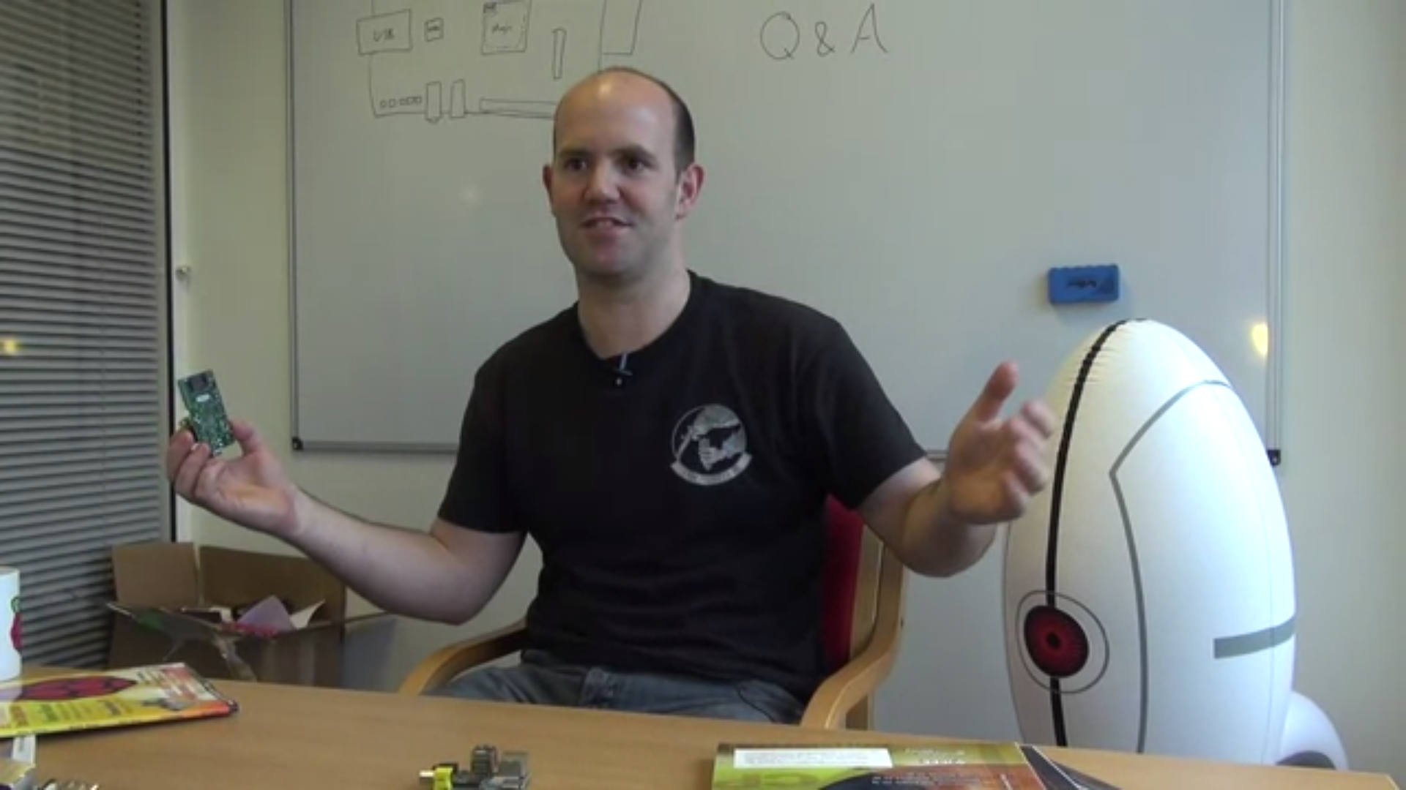

**Online Coding Summary: Today I received the program from prof.Vasudev CSE Dept.The program is mentioned above in the coding challenges.I have written a program and uploaded it to my Github repository, as shown in the below.**

